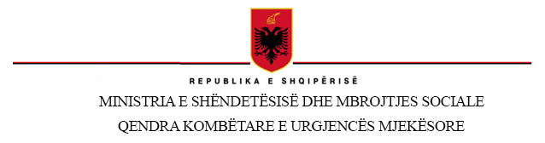
< 13.01.2023 >
Qendra Kombetare e Urgjences Mjekesore-National Center of Medical Emergencies, str. “Lord Bajron”, no.70, Lapraka, Tirana, Albania

Our ref: ITALME-356
INVITATION TO TENDER FOR
External expertise for overall management, Wp t2 “Pilot 1: Infarct.NET in CB territories” and WP t3 “Pilot 2: Platform for Integrated Care Pathways (ICP) in Neurodegenerative diseases (NDDs)”

I am pleased to inform you that your firm is invited to take part in the single tender procedure for the above contract. The complete tender dossier is attached to this letter includes:
- Instructions to tenderers and contract notice
- Draft contract agreement and special conditions with annexes:
- General conditions for service contracts
- Terms of reference
- Organisation and methodology (to be submitted by the tenderer using the template provided)
- Budget (to be submitted by the tenderer as the financial offer using the template provided)
- Forms and other supporting documents
- Other information:
- Administrative compliance grid
- Evaluation grid
- Tender submission form and declaration of honour on exclusion and selection criteria
For full details of the tendering procedures, please see the practical guide and its annexes, which may be downloaded from the following website: https://wikis.ec.europa.eu/display/ExactExternalWiki/ePRAG

We look forward to receiving your tender which has to be sent no later than the deadline set in point 8 of the Instructions to Tenderers. Please send it to the address and with the requirements given in point 8.
By submitting a tender you accept to receive notification of the outcome of the procedure by electronic means. If you decide not to submit a tender, we would be grateful if you could inform us in writing, indicating the reasons for your decision.
Yours sincerely
General Director
Skender Brataj

